Server Decom Spreadsheet
Whenever an application is migrated to Azure, the servers associated with the application will need to be decommissioned. The Providence decom team will determine the timeframe that the servers will be turned off so it’s the responsibility of the 10M engineers to document which associated servers need to be decommissioned when a migration is completed. The document that must be managed is in the Providence Teams channel > 10M Migration Factory > App Migration Requests. The file name is App Migration Update Request.
Ideally, this document will be updated as soon as an application is migrated but, at a minimum, should be updated every Friday. The 10M delivery manager is responsible for reporting on the number of decommissioned servers in each iteration during the weekly status call on Friday afternoons.
Verifying Applications
- Run a query for the completed applications in the specified iteration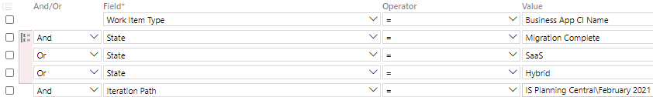
- Sort the results by “Assigned To” 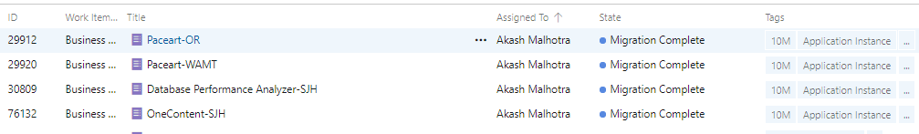
- Confirm each instance assigned to a 10M team member is present on the “App Migration Update Requests” spreadsheet.
  - 10M team is not responsible for the Providence team assigned apps
If an application instance is NOT included on the spreadsheet, follow these steps
- Add the basic information for the app instance in columns A – G, and L on the spreadsheet
  - Migration Date
    - Found in Key Dates on ADO card
  - Migration Disposition
    - Found on State on the ADO card
  - APM Number
    - Found on the ADO card
  - Business App CI
    - The name of the instance
  - On-Prem Server CI
    - Found on the Welcome Kit
  - On-Prem IP
    - Found on the Welcome Kit
  - CMSD Team Lead
    - Found on the ADO card
Confirm with the 10M engineers each Monday to ensure the servers are added to this spreadsheet. If there are missing applications, fill out the basic information and have the engineer fill in the blanks.

